**New Picture Book About Mulan**

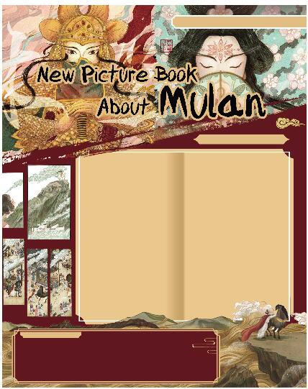

读绘本《木兰辞》，了解不一样的花木兰。

Mulan is a famous heroine (巾帼英雄) in Chinese folklore (民间传说). People first wrote about her 1,500 years ago in a poem (诗). She dressed up as a man to join the army in place of her father.

Since then, people have told the story of Mulan in different forms, such as the new Disney’s live-action film. But a teacher at China Academy of Art shows a different Mulan in her picture book — Mulan is as common as the girl next door. The teacher is Ye Luying.

When Ye studied abroad in 2016, she often missed home and shared Chinese history and culture with foreign friends.

“There are many wonderful stories in Chinese culture, so I thought maybe I could do something to help spread them to move people, like drawing a picture book,” Ye says.

Mulan is a small‑town girl, but she sets off into the world. Ye’s experience is similar to Mulan’s. So that’s also why she drew this book. In her research on Mulan for the picture book, Ye found writers in different times told different stories about Mulan.

In her picture book, Ye puts emphasis on the homecoming of Mulan.

“Mulan is brave enough to go to the battlefield (战场). But in my eyes, the most important thing is that she chooses to return to her hometown after she achieves success and becomes famous. The emperor gives Mulan lots of treasures, but she doesn’t want them. The only thing she cares about is her family. That touches me deeply,” Ye says.

Can’t you wait to get the picture book, can you?